Phase 5
Mobile Application Testing

Executive Summary
The testing of Damn vulnerable Bank (DVBA) application was conducted to reveal vulnerabilities such as insecure data storage, clear text communication, sensitive information logging and excessive permissions. These issues pose threat to privacy of end user and they may end up to data theft and data exfiltration. MobSF analysis scoring tells the overall security posture and violations of several OWASP top 10 mobile controls

Tools used
- Mobile Security Framework (MobSF)
- Frida
- Drozer
- Android Emulator

Static Analysis with MobSF
We will upload the apk to the MobSF for automation of static analysis, which will inspect applications code, its demanding permissions network settings and storage behavior.

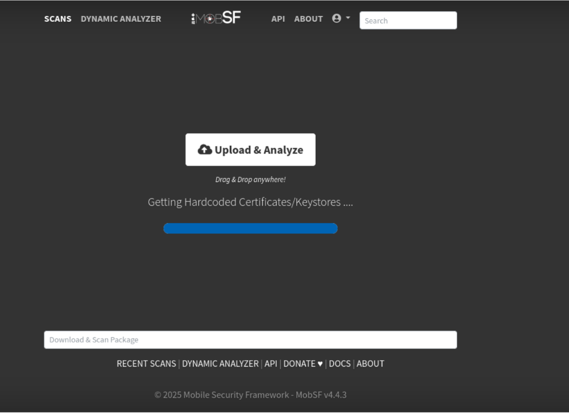

Security Score Overview
The MobSF Security Scoring results lot of vulnerabilities with weak security posture for Damn vulnerable Bank app.
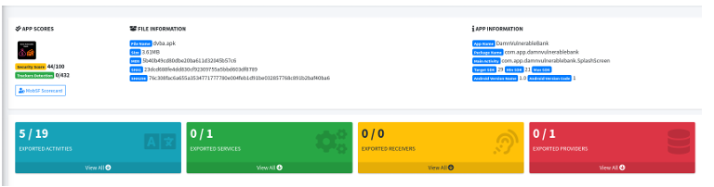
The Overall security score was 44/100. The analysis highlights misconfigurations which expose the app and device to high impact threats. The resistance score is low which tells us that the apps reverse engineering mechanisms are weak.

Findings
The following Table shows the vulnerabilities identified during the static analysis of DVBA apk using MobSF Framework.
Critical Vulnerabilities Findings
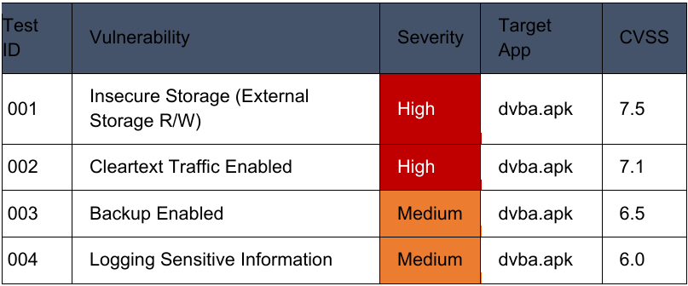
This Static analysis reveals High severity issues particularly insecure storage process and use of clear text communication. Both of these vulnerabilities expose user data under unauthorized access. Further Medium vulnerabilities such as unrestricted Back up facilities and logging sensitive information poses threat to the privacy of the end use which may result in data theft and data exfiltration.

Key Issues Identified:
• Insecure Data Storage: App can read/write to External Storage
• Lack of Encryption: Cleartext HTTP traffic enabled
• Data Exposure: Backup allowed via ADB
• Information Leakage: Sensitive data logged

Vulnerability Logging
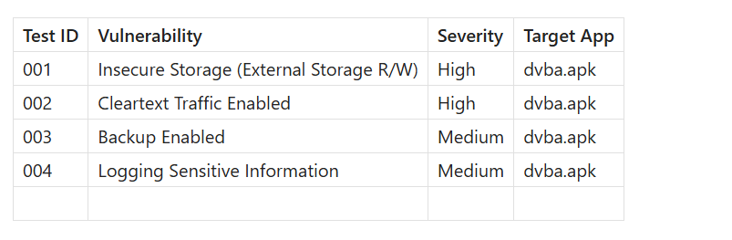

Summary
The Static analysis of the DVBA Apk with MobSF resulted in a weak secured posture meaning it had very high to medium impact vulnerabilities. Insecure storage,
Unencrypted traffic, Unauthorized backups, Secretive loggings which all point to an very weakly designed application with lot of loopholes. The app lacks essentials protections which significantly increases attack surface putting end user at risk.

